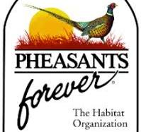Scott County Pheasants Forever

Conservationist Scholarship

2025

This scholarship is available to Scott County students who are graduating high school in the 2024-2025 school year. If you are interested in obtaining this one time $500 scholarship, please write a one-page essay highlighting the effects of conservation on you as well as your contribution to maintaining our natural resources. We want to hear why you are involved in the outdoors and how you give back to the community.

The scholarship will come in the form of a check for the amount, which will be presented after the recipient has been decided. The funds can be used for anything related to higher education, whether that be tuition, book, other materials, etc. It is available for any type of higher education such as traditional college, trade school, CDL classes, etc.

Entries need to be submitted by May 31, 2025. If this interests you, please submit your essay to Scott County Pheasants Forever by email at [scottcountypf0947@gmail.com](mailto:scottcountypf0947@gmail.com)

Requirements to apply:

Scott County School System

Graduating Senior in High School

Seeking higher education

Please include name, school you are graduating from, and contact info (email or phone) as a header

Scott County Pheasants Forever